# Introduction

The metal3 is a certified CNCF Sandbox project developed by Red Hat Software. It provides for bare metal host management with Kubernetes. You can enrol your bare metal machines, provision operating system images, and then, if you like, deploy Kubernetes clusters to them. From there, operating and upgrading your Kubernetes clusters can be handled by Metal3. It is a revolutionary tool that differs from similar implementations by being self-hosted and does not rely on 3rd parties like google cloud or AWS.

# Goals and missions

The project's vision is to enable users to efficiently deploy and manage bare metal infrastructure at scale, using the same tools and principles as they do for containerized workloads in Kubernetes. By providing a Kubernetes-native API and toolchain for bare metal infrastructure, Metal³ aims to make it easier to adopt and integrate bare metal into modern, cloud-native architectures.

The mission of Metal³ is to develop an open, collaborative community around bare metal infrastructure automation and management. This includes developing and maintaining open-source software components that can be used to deploy, manage, and monitor bare metal infrastructure using Kubernetes, as well as providing education and resources to help users adopt and contribute to the project. The goal is to create a vibrant ecosystem of developers, users, and vendors working together to advance the state of bare metal infrastructure automation and management.

# Components

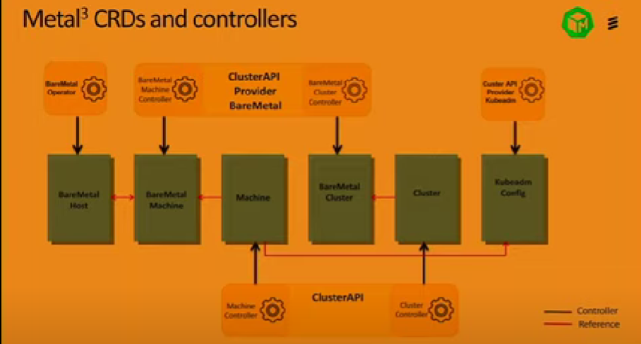

## Bare Metal Acutator

The first component is the Bare Metal Actuator, which is an implementation of the Machine Actuator interface defined by the cluster-api project. This actuator reacts to changes to Machine objects and acts as a client of the BareMetalHost custom resources managed by the Bare Metal

The Cluster API brings declarative, Kubernetes-style APIs to cluster creation, configuration and management. The API itself is shared across multiple cloud providers. Cluster API Provider Metal3 is one of the providers for Cluster API and enables users to deploy a Cluster API based cluster on top of bare metal infrastructure using Metal3.

## Bare Metal Operator

The architecture also includes a new Bare Metal Operator, which includes the following: A Controller for a new Custom Resource, BareMetalHost. This custom resource represents an inventory of known (configured or automatically discovered) bare metal hosts. When a Machine is created the Bare Metal Actuator will claim one of these hosts to be provisioned as a new Kubernetes node. In response to BareMetalHost updates, the controller will perform bare metal host provisioning actions as necessary to reach the desired state. The creation of the BareMetalHost inventory can be done in two ways: Manually via creating BareMetalHost objects. Optionally, automatically created via a bare metal host discovery process. It can

* Inspect the host’s hardware details and report them on the corresponding BareMetalHost. This includes information about CPUs, RAM, disks, NICs, and more.
* Provision hosts with a desired image.
* Clean a host’s disk contents before or after provisioning.

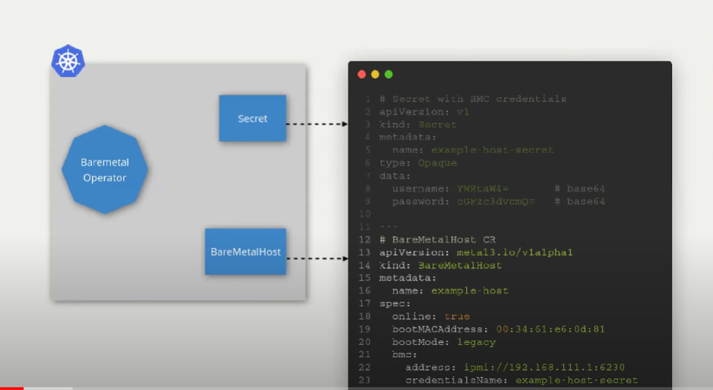

It has Secret attached to it that contains username and password for the BMC.

## Ironic

Ironic is an open-source service for automating provisioning and lifecycle management of bare metal machines. Born as the Bare Metal service of the OpenStack cloud software suite, it has evolved to become a semi-autonomous project, adding ways to be deployed independently as a standalone service, for example using Bifrost, and integrates in other tools and projects, as in the case of Metal3.

## Bare metal management pods

The operator manages a set of tools for controlling the power on the host, monitoring the host status, and provisioning images to the host. These tools run inside the pod with the operator, and do not require any configuration by the user